

PHILOSOPHY AND ETHICS SAMPLE DRAFT SAMPLE EXAMINATION

Section 7 of the WACE Manual: 2008 Revised Edition outlines the policy on WACE examinations.

Further information about the WACE Examinations policy can be accessed from the Curriculum Council website at http://curriculum.wa.edu.au/

The purpose for providing a sample examination is to provide teachers with an example of how the course will be examined. Further finetuning will be made to this sample in 2008 by the examination panel following consultation with teachers, measurement specialists and advice from the Assessment, Review and Moderation (ARM) panel.

2008/23253




Western Australian Certificate of Education, Sample Draft Sample Examination
Question/Answer Booklet

PHILOSOPHY AND
Please place your student identification label in this box
ETHICS
WRITTEN EXAM
STAGE 2

Student Number: In figures

In words

Time allowed for this paper
Reading/planning time before commencing work: Ten minutes
Working time for paper: Three hours

Material required/recommended for this paper

To be provided by the supervisor
Question/Answer Booklet (Section One)
Answer Booklet (Sections 2 and 3)

To be provided by the candidate
Standard items: Pens, pencil, eraser, correction fluid, highlighter and ruler.
Special items: Nil

Important note to candidates
No other items may be taken into the examination room. It is your responsibility to ensure that you do not have any unauthorised notes or other items of a non-personal nature in the examination room. If you have any unauthorised material with you, hand it to the supervisor before reading any further.
Structure of this paper

Section | Suggested working time | Number of questions available | Number of questions to be attempted | Marks available
Section One | 50 minutes | 16 | 16 | 30
Section Two | 80 minutes | 2 | 2 | 40
Section Three | 50 minutes | 5 | 1 | 30
 |  |  | [Total marks] | 100

Instructions to candidates

- The rules for the conduct of Curriculum Council examinations are detailed in the Student Information Handbook. Sitting this examination implies that you agree to abide by these rules.

- For Section One you are to answer the questions in the space provided immediately after each question in this Question/Answer Booklet

- For Sections Two and Three write your answers in a separate Answer Booklet. A blue or black ballpoint or ink pen should be used.

- You must be careful to confine your responses to the specific questions asked and to follow any instructions that are specific to a particular question.

- Spare answer pages may be found at the end of this booklet. If you need to use them, indicate in the original answer space where the answer is continued (i.e. give the page number).

SECTION ONE—REASONING AND INQUIRY SKILLS [30 marks]

In this section there are SIXTEEN (16) questions. Complete ALL questions and ALL parts.

Suggested working time: 50 minutes

Question 1
Classify each of the following passages as description, explanation or argument.

- The harvest has been a poor one because there was no rain late in the season.
[1 mark]

- We should all become vegetarians because meat-eating requires the killing of conscious intelligent animals.
[1 mark]

- Unemployment levels rose sharply, after the new government came to power.
[1 mark]

Question 2
What is the technical name for the following type of reasoning?

If we really wanted to save money, we would give up going to the races every weekend. But we won’t give up going to the races, so we don’t really want to save money.
[1 mark]

Question 3
Is the following inference an example of inductive or deductive reasoning?

Since Paul is taller than Lara, and Lara is taller than Kate, Paul is taller than Kate.
[1 mark]

Question 4
Is the following inference an example of inductive or deductive reasoning?

Global temperatures have been rising slowly for a century, so they will continue to rise in the future.
[1 mark]

Question 5
What is the technical name for the following formal fallacy?

If you grew up in the country, you will like country music. But you did not grow up in the country, so you do not like country music.
[1 mark]

Question 6
What is the technical name for the following form of reasoning?

If there is dog food in the cupboard, then the owners of this house must have had a dog. There is dog food in the cupboard. It follows that the owners did have a dog.
[1 mark]

Question 7
What is the technical name for the following formal fallacy?

If you study hard, you will do well at school. You did do well at school, so you did study hard.
[1 mark]

Question 8
Explain why the following is a fallacious argument. In your explanation, name the fallacy.

Those people are just a bunch of losers, jerks and idiots, so you should certainly not believe anything they say.
[2 marks]

Question 9
Identify the premise and the conclusion in the following argument.

If you ever go to the Stirling Ranges, make sure you climb Bluff Knoll, since the view from the top is magnificent.

The premise is:
[1 mark]

The conclusion is:
[1 mark]

Question 10
Explain why the following is a fallacious argument. In your explanation, name the fallacy.

No one has ever proven that regular study and proper sleep are necessary for academic success, so it follows that it is quite possible to succeed academically without studying regularly and sleeping well.
[2 marks]

Question 11
Identify the premise and the conclusion in the following argument.

The black cockatoo is increasingly losing its nesting sites in the southwest forests, and for that reason it is classified as an endangered species.

The premise is:
[1 mark]

The conclusion is:
[1 mark]

Question 12
Identify the premise and the conclusion in the following argument.

It is a bad idea to buy a cheap car, since it will break down often and cost too much in maintenance.

The premise is:
[1 mark]

The conclusion is:
[1 mark]

Question 13
Explain why the following is a fallacious argument. In your explanation, name the fallacy.

There are many examples of false advertising on television, so you should never believe what they say in TV advertisements.
[2 marks]

Question 14
Evaluate the strength of the inference in the following argument. Justify your answer.

No dog has ever written an essay, read a book, invented a new technology, or run for Parliament. It follows that, contrary to popular opinion, dogs are not intelligent animals.
[3 marks]

Question 15
Evaluate the strength of the inference in the following argument. Justify your answer.

All the relevant medical and physiological experts agree that regular exercise and proper nutrition are necessary for weight loss, so it follows that it is not sensible to try to lose weight without exercising regularly and eating well.
[3 marks]

Question 16
What is hermeneutics? Give an example and discuss its use.
[3 marks]

END OF SECTION ONE
SECTION TWO—PHILOSOPHICAL ANALYSIS [40 marks]

This section contains TWO (2) parts. Each part has ONE (1) question. Answer ALL questions and address ALL texts. Write your response in the separate answer booklet.

Suggested working time: 80 minutes

PART A—Community of inquiry transcript

Question 17
Read the following transcript. Analyse the contribution made by ONE participant in the following community of inquiry. In your evaluation consider the following:
      - relevance
      - respect for persons and ideas
      - clarity of thought
      - cogency of argument. [20 marks]

The following discussion is based on a 26 minute documentary called Veiled Ambition (2006). Frida, a young Australian-Lebanese woman has a dream to create a fashion empire. She opens a shop in Melbourne to sell Muslim clothes but is not successful. She then successfully imports and sells glamorous American fashion clothes despite family difficulties. Ms Graham opens the discussion by asking if it is possible for a Muslim to be a true Aussie battler.

For copyright reasons this text cannot be reproduced in the online version of this document.

PART B—Analysing, clarifying and evaluating concepts

Question 18
Examine closely the THREE (3) texts and answer the following question. Discuss the relationship between technology and ethics in EACH text and give reasons for your answers.
[20 marks]

- Food for thought

For copyright reasons this text cannot be reproduced in the online version of this document, but may be viewed at http://www.abc.net.au/rn/ockhamsrazor/stories/2006/1669374.htm.

[Adapted from: Kamien, 2007]

(ii) How to buy organic apples

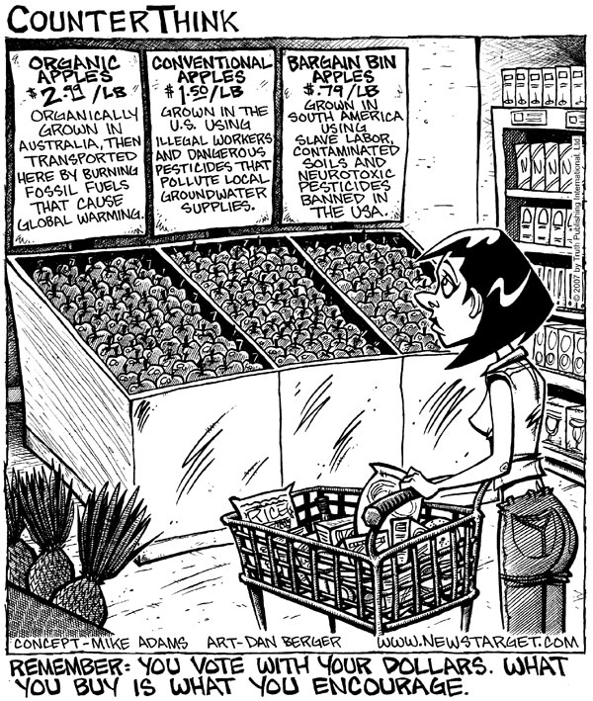

(iii) Saving Water and Energy

For copyright reasons this text cannot be reproduced in the online version of this document.

[Flannery, 2007]

END OF SECTION TWO
SECTION THREE—EXTENDED ARGUMENT [30 marks]

This section contains FIVE questions. Answer ONE question only. Write your response in the separate answer booklet.

Suggested working time: 50 minutes

Choose ONE (1) question from the following FIVE (5) questions. Argue FOR or AGAINST the question with clear definitions, examples and reasons.
[30 marks]

Question 19
A person has been defined as ‘a conscious or rational being.’ How useful is this definition?

OR

Question 20
Someone says, ‘He made me do it.’ How adequate is this as an excuse or an explanation?

OR

Question 21
What are the differences, if any, between dreams and illusions?

OR

Question 22
Are actions different from behaviours?

OR

Question 23
What would make an apple in an art gallery a work of art?

ACKNOWLEDGEMENTS

SECTION TWO

PART A

Question 17 Geer, C. (Writer & director), & McMahon, J. (Producer). (2006). Veiled ambition [DVD]. Brunswick, Vic: Rebel Films.

PART B

Question 18(i) Kamien, M. (2007). Lies, deep fries and statistics (Food for thought). Sydney: ABC Books, pp. 180–187.

Question 18(ii) Cartoon from: Berger, D. (2007, September 18). How to buy organic apples (comic). Retrieved February, 2008, from Natural News website: http://www.naturalnews.com/022040.html.

Question 18(iii) Flannery, T. (2007). An explorer’s notebook. Melbourne: Text Publishing, p. 256.

Published by the Curriculum Council of Western Australia
27 Walters Drive
OSBORNE PARK WA 6017

